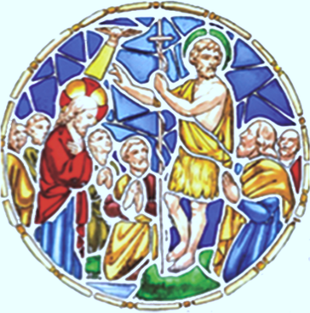 | St John the Baptist  Scottish Episcopal  Church, Perth
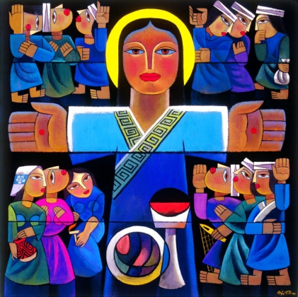

Easter Day

Lighting of the Paschal Candle Please stand

The Paschal Candle is it at the back of the Church

Christ, yesterday and today, the beginning and the end,

Alpha and Omega all time belongs to him,

and all the ages; to him be glory and power,

Through every age for ever. Amen

By his holy and glorious wounds may Christ our Lord

guard us and keep us. Amen

And may the light of Christ

rising in glory, banish all darkness from our hearts and minds.

Amen

The Light of Christ

Thanks be to God

Alleluia! Christ is Risen!

He is risen indeed, Alleluia!

Processional Hymn

Grace and peace to you from God our Father
and the Lord Jesus Christ.
Amen.

Welcome and Intimations

Collect for Purity Sit or kneel

Almighty God,
to whom all hearts are open,
all desires known,
and from whom no secrets are hidden:
cleanse the thoughts of our hearts
by the inspiration of your Holy Spirit,
that we may perfectly love you,
and worthily magnify your holy name;
through Christ our Lord. Amen.

Confession and Absolution

God is love and we are his children.
There is no room for fear in love.
We love because God loved us first.

Let us confess our sins in penitence and faith.

God our Father, we confess to you and to our fellow members in the Body of Christ that we have sinned in thought, word and deed, and what we have failed to do. We are truly sorry. Forgive us our sins and deliver us from the power of evil, for the sake of your Son who died for us, Jesus Christ, our Lord.

God, who is both power and love,
forgive you and free you from your sins,
heal and strengthen you by his Spirit,
and raise you to new life in Christ our Lord. Amen
The Gloria

Glory to God in the highest,
and peace to His people on earth.
Lord God, heavenly king, almighty God and Father,
we worship you, we give you thanks,
we praise you for your glory.
Lord Jesus Christ, only Son of the Father,
Lord God, Lamb of God,
you take away the sin of the world: have mercy on us;
you are seated on the right hand of the Father;
receive our prayer.
For you alone are the Holy One,
you alone are the Lord,
you alone are the Most High,
Jesus Christ, with the Holy Spirit,
in the glory of God the Father. Amen

Collect of the day

Almighty God, who through your Son, Jesus Christ, have overcome death and opened the gates of eternal life: grant that we, who celebrate with joy the day of his resurrection, may be raised from the death of sin by your life – giving Spirit: through the same Jesus Christ, our Lord, who live and reigns with you, in the unity of the Holy Spirit, one God, world without end. Amen

First reading

Second reading

Gradual Hymn Stay standing

The Gospel

Sermon Sit

Anthem

Nicene Creed Stand

We believe in one God,
the Father, the almighty,
maker of heaven and earth,
of all that is, seen and unseen.
We believe in one Lord, Jesus Christ,
the only Son of God,
eternally begotten of the Father,
God from God, Light from Light,
true God from true God,
begotten, not made,
of one substance with the Father.
Through him all things were made.
For us and for our salvation
he came down from heaven;
by the power of the Holy Spirit
he became incarnate of the Virgin Mary,
and was made human.
For our sake he was crucified under Pontius Pilate;
he suffered death and was buried.
On the third day he rose again
in accordance with the Scriptures;
he ascended into heaven
and is seated at the right hand of the Father.
He will come again in glory to judge the living and the dead,
and his kingdom will have no end.
We believe in the Holy Spirit, the Lord, the giver of life,
who proceeds from the Father.
With the Father and the Son, he is worshipped and glorified.
He has spoken through the Prophets.
We believe in one holy catholic and apostolic Church.
We acknowledge one baptism for the forgiveness of sins.
We look for the resurrection of the dead,
and the life of the world to come. Amen

Intercessions
Prayer is offered for the world and its people.

The Peace
The risen Christ came and stood among his disciples and said, ‘Peace be with you.’ Then they were glad when they saw the Lord. Alleluia!

The peace of the risen Christ be always with you
And also with you. Alleluia!

Let us offer once another the sign of peace. (We greet each other)

Offertory Hymns

Prayers of Offering

Blessed are you, Lord God of all creation; through your
goodness we have this bread to offer, which earth has given
and human hands have made: it will become for us the bread
of life.
Blessed be God for ever.
Blessed are you, Lord God of all creation; through your
goodness we have this wine to offer, fruit of the vine and work
of human hands; it will become the cup of our salvation.
Blessed be God for ever.

Eucharistic Prayer

The Lord be with you.
And also with you.
Lift up your hearts.
We lift them to the Lord.
Let us give thanks to the Lord our God,
It is right to give our thanks and praise.

Worship and praise belong to you, Author of all being.
Your power sustains, your love restores, our broken world.
You are unceasingly at work,
from chaos bringing order
and filling emptiness with life.

Christ, raised from the dead,
proclaims the dawn of hope.
He lives in us that we may walk in light.

Your Spirit is fire in us,
your breath is power
to purge our sin
and warm our hearts to love.
As children of your redeeming purpose,
freed by him who burst from the tomb
and opened the gate of life,
we offer you our praise,
with angels and archangels
and the whole company of heaven,
singing the hymn of your unending glory:

Holy, holy, holy Lord
God of power and might.
Heaven and earth are full of your glory.
Hosanna in the highest.
Blessed is he who comes in the name of the Lord.
Hosanna in the highest.

Praise and thanksgiving be to you, Lord of all,
for by the Cross eternal life is ours
and death is swallowed up in victory.
In the first light of Easter
glory broke from the tomb
and changed the women's sorrow into joy.
From the Garden the mystery dawned
that he whom they had loved and lost
is with us now
in every place for ever.

Making himself known in the breaking of the bread,
speaking peace to the fearful disciples,
welcoming weary fishermen on the shore,
he renewed the promise of his presence
and of new birth in the Spirit
who sets the seal of freedom on your sons and daughters.
Before he was given up to suffering and death,
recalling the night of Israel's release,
the night in which slaves walked free,
at supper with his disciples
he took bread and offered you thanks.
He broke the bread,
and gave it to them, saying:
‘Take, eat. This is my Body: it is broken for you.’
After supper, he took the cup,
he offered you thanks,
and gave it to them saying:
‘Drink this, all of you.
This is my Blood of the new covenant;
it is poured out for you, and for all,
that sins may be forgiven.
Do this in remembrance of me.’

We now obey your Son's command
We recall his blessed passion and death,
his glorious resurrection and ascension;
and we look for the coming of his Kingdom.
Made one with him, we offer you these gifts
and with them ourselves a single, holy living sacrifice.

Hear us, most merciful Father,
and send your Holy Spirit upon us
and upon this bread and this wine,
that, overshadowed by his life-giving power,
they may be the Body and Blood of your Son,
and we may be kindled with the fire of your love
and renewed for the service of your Kingdom.

Help us,
who are baptised into the fellowship of Christ's Body
to live and work to your praise and glory;
may we grow together in unity and love
until at last, in your new creation,
we enter into our heritage
in the company of the Virgin Mary,
the apostles, and prophets,
and of all our brothers and sisters
living and departed.

Through Jesus Christ our Lord,
with whom, and in whom,
in the unity of the Holy Spirit,
all honour and glory be to you,
Lord of all ages,
world without end. Amen

The Breaking of the Bread

The living bread is broken for the life of the world.
Lord, unite us in this sign.
Sit or kneel

The Lord’s Prayer

As our Saviour has taught us, so we pray:

Our Father in heaven,
hallowed be your name,
your kingdom come,
your will be done,
on earth as in heaven.
Give us today our daily bread.
Forgive us our sins
as we forgive those who sin against us.
Do not bring us to the time of trial
but deliver us from evil.
For the kingdom, the power
and the glory are yours,
now and for ever. Amen

Communion Song

Lamb of God, you take away the sins of the world: have mercy on us.
Lamb of God, you take away the sins of the world: have mercy on us.
Lamb of God, you take away the sins of the world: grant us peace.

Communion

Alleluia. Christ our Passover is sacrificed for us.

Therefore let us keep the feast. Alleluia!

All are welcome to come forward
to receive Communion or a blessing.

Communion Hymns

Thanksgiving

Give thanks to our Gracious God.
Whose mercy endures for ever.

Post Communion Prayer

God of Life, who for our redemption gave your only-begotten Son to the death of the cross, and by his glorious resurrection have delivered us from the power of our enemy: grant us so to die daily to sin, that we may evermore live with him in the joy of his risen life; through Jesus Christ our Lord. Amen

The Blessing

The God of peace who brought again from the dead our Lord Jesus, that great shepherd of the sheep, through the blood of the eternal covenant, make you perfect in every good work to do his will, working in you that which is well-pleasing in his sight And the blessing of God almighty, the Father, the Son and the Holy Spirit, be among you, and remain with you always. Amen

Final Hymn

Dismissal
Go in peace to love and serve the Lord. Alleluia!
In the name of Christ. Alleluia! Amen.

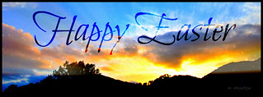

St John the Baptist Scottish Episcopal Church,
Princes Street, Perth, PH2 8LJ

A church where all are welcome

Rector, The Very Revd Graham S. Taylor
Assistant Priest, Revd Annie MacKay Hughes
Assistant Priest, Revd Mariusz Wojciechowski

Office phone number, 01738 634999
Scottish Charity No. SC011398

