 St John the Baptist

Scottish Episcopal Church

Perth

 Q

U

E

S

T

April and May 2019

Dear friends,

Letter from the Rector

Dear Friends,

I write this well into Lent now, a special time for us all to reflect upon our lives as we dedicate ourselves to God once more. As we prepare for the wonderful celebrations of Easter once again, a time to call out ‘Christ has Risen’.

It’s been great for us as a congregation to host ecumenical Compline with a Reflection given by different folks around our Churches in Perth. It is a wonderful thing when we can worship together and learn from each other. Thank you to those who have supported this in any way.

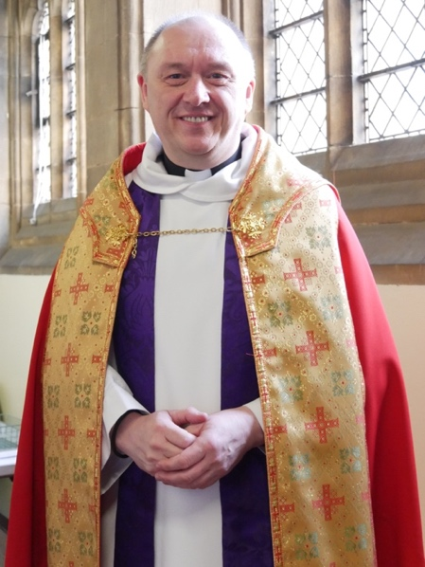During all of this of course it has been a real celebration for me, being appointed by my colleagues as Canon of St. Ninian’s Cathedral and in our diocese. I feel both humbled and privileged. I thank Bishop Ian for all his love and words and for a wonderful Eucharist where I was installed. It was great to see so many of you coming along for that. I must say a sincere thank you here to all of you who made it so special in lots of ways. What a great celebration you gave me after the Sunday service along with amazing cakes and a nice bottle of something very special. As I remarked after Bishop Bruce’s kind comments on the day, how privileged I feel to serve such wonderful folks here in St. John’s and in our community beyond.

I hope you all have a very happy Easter and I look forward to seeing you in Church over some of the events.

Blessings,

Graham.

Services in April and May

***Weekly Services***

Sunday 8.30 a.m. Holy Communion

Sunday 10.30 a.m. Sung Eucharist

Thursday 10 a.m. Prayer Gathering

Thursday 11 a.m. Communion, coffee and a chance to chat

***Special Services***

7th April 9.30 a.m. Matins

14th April 10.30 a.m. Palm Sunday

18th April 7.30 pm. Maundy Thursday

19th April 12 noon 3 hours Devotion – Bishop Ian:

Stations of Pain

21st April 10.30 a.m. Easter Day

5th May 9.30 a.m. Matins

19th May 6.00 p.m. Evensong

26th May 6.00 p.m. Nitekirk

From the Registers – Eternal Rest

Albert Murray died 10th February 2019 (aged 83 years)

Ken Miles died 22nd January 2019 (aged 91 years)

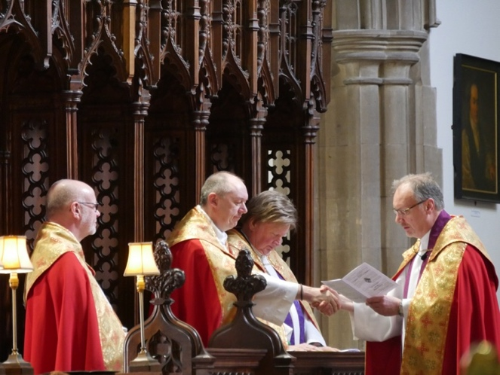

Canon of St Ninian’s Cathedral

*Graham being installed in his chair by the Very Reverend HB Farquharson; Very Reverend K Rathband on left.*

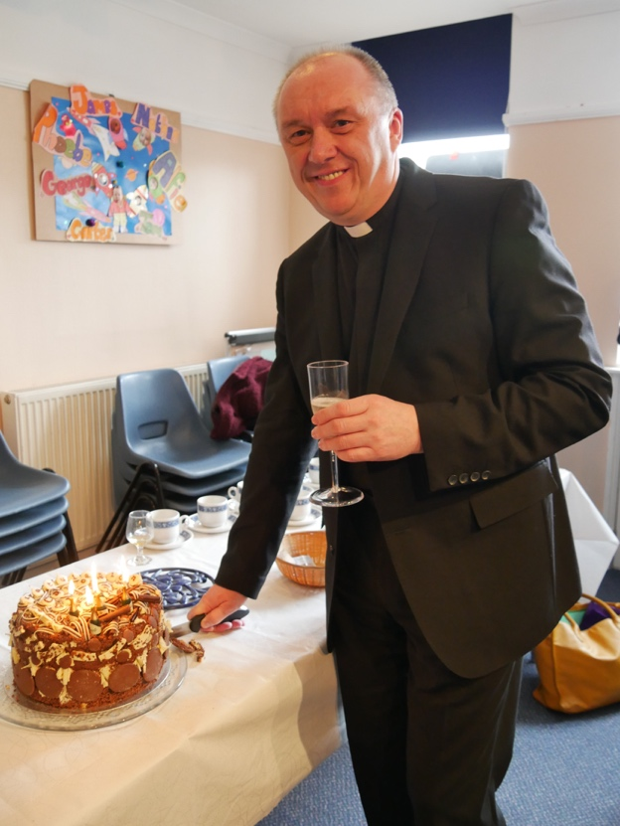

*Graham with celebration cake and some bubbly!*

St John’s Fellowship

As anticipated in the February / March Quest Ian Scott’s presentation of his photographs was enjoyed by all. What had actually been photographed was very varied and included things that it would never have occurred to me to take a photo of but the results were very impressive. As I write this I have above my desk this year’s Diocesan calendar and I am looking at the March photo which is a lovely photo taken by Ian. It is a picture of a few heads of bog cotton, a plant, very familiar to me as a hill walker, which adds to landscape in general but I would have never thought of taking a photo of - just a few heads of bog cotton!

For our April meeting we look forward to welcoming Catherine Meikle who is the acting convener of the Scottish Episcopal Church Mission Organisation (SECMA). She will be giving an illustrated talk about some of SECMA’s overseas projects. This is something which we support each year with a donation from the proceeds of our Spring Coffee morning, so it will be good to learn more about how this money is spent.

This year’s Spring Coffee morning will be held on Saturday 13th April in the Threshold with the proceeds being distributed between various charities including SECMA. We hope it will be well supported by the congregation and their friends.

Jean Hendry



[This Photo](http://icehand84.deviantart.com/art/Spring-flowers-362913711) by Unknown Author is licensed under [CC BY](https://creativecommons.org/licenses/by/3.0/)

**Christian Aid Week May 12 - 18**

Our Rector is hoping that Sunday May 12 will be an extra special start to Christian Aid Week at St John’s this year. He is delighted to have secured a Christian Aid staff member**, Dr Rachel Tavernor**, to speak about their work at our **10.30 morning service on Sunday May 12**, the start of Christian Aid Week. I know Rachel a little – she is passionate about the power of storytelling to provoke social change, and I am sure her background in youth work, campaigns and research makes her an inspiring speaker. Hopefully some of the other PACT congregations may join us that morning.

Rachel will also be the chief guest at our Christian Aid Lunch that day, in the Threshold following the service. More details soon – meantime, note that there will be a **Christian Aid Lunch Sunday May 12.**

***A note about Door to Door collections 2019***

St John’s will have four collectors this year; some will only go to houses where they are known, or where they anticipate a generous donation.

Christian Aid are very aware that collectors are depleting – so they are trying to make the house-to-house collecting easier. Along with the tradition pattern of leaving the envelope, then returning to collect it, this year there are alternatives:

*Delivery only – No-reply envelopes:* to be delivered, but not collected. There will be a drop-off address for donations. (Drop-off points not yet confirmed.)

*Usual envelopes but one stop collection – collectors may knock, give the envelope, and accept an immediate donation.*

***Church collection envelopes*** *–* with an inspiring Bible quote – to place at back of church. These would be for those of you whose area is no longer covered by house-to-house collectors – we are NOT anticipating two envelope donations from anyone!

**The difference Christian Aid makes**

Last November, I was privileged to meet Amanda Mukwashi, the new Christian Aid CEO. She was inspirational in describing many of the places she had visited since taking over. In June 2018, she visited Rohinga refugees in Jamtoli camp, run by Christian Aid and local partners. She described the difference our support is making, like the newly constructed latrines replacing the open sewers. Or, after concerns were raised over safety and protection for women, the safe spaces for women to meet in public. One woman said they were a place of refuge in the camp: 'We are happy to be here and learn. We feel good in the women's spaces compared to being at home. Here, we can meet other women and learn from each other.’

Visit the website: www.christianaid.org.uk

Christian Aid Coffee Morning Saturday 11 May

North Church 10.00 – 11.45 £3

Donations of baking, bric-a-brac, books, plants welcome

CA Paper Quiz – pit your wits against a book-themed quiz

£1.00 per sheet from Elaine

Saturday 11 May

Tay Bridge Challenge – 2.00pm for 3 hours

Saturday 11 May – Friday 17 May

##### [St Andrews and St George's West Book Sale](https://www.christianaid.org.uk/events/st-andrews-and-st-georges-west-book-sale)

##### Edinburgh EH2 2PA

Any questions or offers? *Elaine Cameron elaine.ging@gmail.com*

AGM from Quest Easter 1969

Fifty-five (about one in twelve) of our members met in the Church Hall on Wednesday, 5th March. There were a number of apologies owing to illness and the weather. After dealing with the Minutes and the Accounts, which were duly passed, the following were elected to the Vestry: Mr. J.P. Mahon, Miss C.A. Elliott and Miss A. Jackson. Mr. A.J. Young was re-elected People’s Warden and the Rector nominated Colonel P.C. Hunter as Rector’s Warden. Wing Commander R. E. Stevenson had already been elected Lay Representative at a special meeting in January.

The main business of the meeting was concerned with Stewardship. While the Accounts had drawn attention to the reduction in numbers of pledged givers through the Envelope Scheme or Deeds of Covenant, it was felt that there must be a strong emphasis on Time and Talents. Accordingly, two main decisions were reached. First, that there should be a regular annual Stewardship Service at which members might re-pledge their giving, and the congregation dedicate some active use of time and talents. Secondly, the existing Committee, which had carried out a visitation of members who had come to the area since the original campaign, was thanked for their efforts and discharged. Wing Commander Stevenson was re-appointed Convener, and the Vestry instructed to appoint a small new committee to work with him.

Other matters discussed in relation to Stewardship included the question of whether the boxes of Offering Envelopes should continue to be left at the back of the Church to be picked up, or whether they should be delivered; the matter of a Transport Rota was discussed and remitted to the new Committee.

Under Other Competent Business it was suggested that a fresh appeal should be made for volunteers to clean the brasses and to help with the Altar Flowers. Anyone interested to help in these ways should get in touch with Mrs P.M. Watson, 3 Murray Terrace for brasses and with Muiss C.G. Moncrieff, 4 Strathview Terrace for flowers.

Sunday Lectionary

**April 7 Passion Sunday**

Matins Psalm 30, Lam 3. 19-33, Matt 20. 17-34

Isaiah 43. 16-21 John 12.1-8

**April 14 Palm Sunday**

Isaiah 50. 4-9a

Luke 22. 14-23, 56

**April 21 Easter Day**

Isaiah 65. 17-25

John 20. 1-18

**April 28 2nd Sunday of Easter**

Psalm 118. 14-29

Refrain: Give thanks to the Lord, for he is good; his mercy endures for ever.

Rev 1. 4-8 John 20. 19-31

**May 5 3rd Sunday of Easter**

Matins Psalm 48, Hag 13,

John 2. 13-22

Psalm 30

Refrain: I will exalt you O Lord, because you have lifted me up.

Rev 5. 11-14 John 21. 1-19

**May 12 4th Sunday of Easter**

Psalm 23

Refrain: The Lord is my shepherd, I shall not want.

Rev 7. 9-17 John 10. 22-30

**May 19 5th Sunday of Easter**

Psalm 148

Refrain: Praise, O praise the name of the Lord.

Rev 21. 1-6 John 13. 31-35

Evensong: Psalm 96, Zech 4. 1-10, Luke 2. 25-32 (33-38)

**May 26 6th Sunday of Easter**

Psalm 67

Refrain: Let the peoples praise you, O God; let all the people praise you.

Rev 21. 10, 22-25

John 14. 23-29

**May 30 Ascension Day**

Psalm 47

Refrain: God is gone up with a shout, the Lord with the sound of the trumpet.

Ephes 1. 15-53 Luke 24. 44-53

Nitekirk – A Reflection

How often have you said: ‘I don’t do Meditation – it’s just not for me.’?

That was me until the last time Sunday evening Nitekirk was announced. I went along to find a silent church being quietly prepared by a small team into a number of areas to use either to pray or to complete a small task. A sheet of things to do was handed to me and I went to the front row by the pulpit to read it through.

I remained there for over an hour and found complete peace to think back on the way St John’s had enveloped me in regular worship of the Lord amongst a wonderful church family. ‘Is this Meditation?’ I wondered and if so I can do it quite easily. Time will tell as the next Nitekirk will find me there but perhaps to move around the spaces as we are invited to do.

If you can join us you will find it very rewarding. Approach it in your own way and you will fit right in.

Doreen Kneller

Just for Fun!

I love mathematics! I know that not everyone shares this appreciation including – despite my best efforts - many of those I teach. But for me the beauty of mathematics is part of the wonder of God’s creation.

I also enjoy puzzles! For those of you who might enjoy a little brain exercise I include one here, selected for its church context! (No advanced maths required – just some gentle arithmetic with a twist!)

Have fun!

|  |  |  |
| --- | --- | --- |
| **1** | **1** | **3** |
|  | | |
| **4** | **2** | **4** |
|  | | |
| **5** | **7** | **5** |
|  | | |
| **8** | **9** | **8** |
|  | | |

Cath

There are to be four hymns sung at the service. The numbers have been displayed on the hymn board using 12 cards.

Can you move just two single cards so that all three vertical columns add up to the same total? In each column the four cards must all be different digits.

Music at St John’s

**Dates for your diary:**

**Wednesday 26th June, 6.00 p.m.**:

Organ Recital by Geoff Bolton, Organist at St Ninian’s Cathedral

**Sunday September 8th, 6.00 p.m.**:

Organ Recital by Alexander Wallace, Organ Scholar of St Catherine’s College, Cambridge

**Friday 11th October, 7.30 p.m.**:

Plaidsong – Scottish history through song - Nicky Small and Syd House

**Sunday 17th November, 7.30 p.m.**:

Ferntower Jazz, with Gordon Murch

There will be a retiring collection with funds raised being used for projects within our own church fellowship. It is hoped that members of St John’s will come along to support these events and also will promote them to friends, family and neighbours.

Refreshments will be available after the last two events.

David Willington



[This Photo](https://blogs.commons.georgetown.edu/cctp-748-spring2013/2013/05/06/draft/) by Unknown Author is licensed under [CC BY-NC-ND](https://creativecommons.org/licenses/by-nc-nd/3.0/)

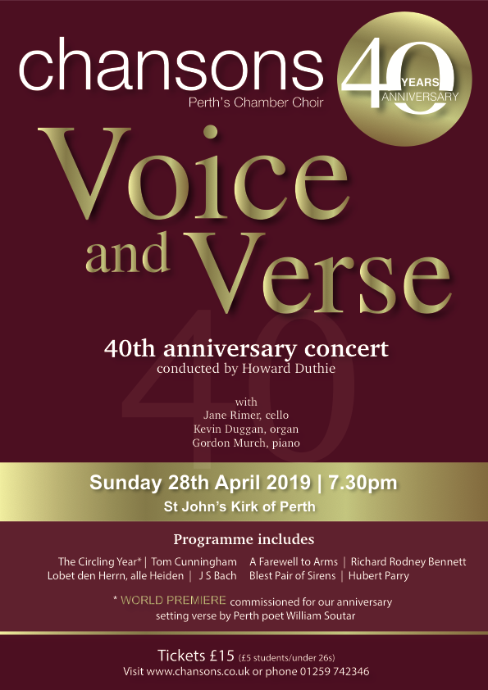

Contact Information

|  |  |  |  |
| --- | --- | --- | --- |
| Rector | Rev Canon Graham Taylor | 245922 | [*rector@episcopal-perth.org.uk*](mailto:rector@episcopal-perth.org.uk) |
| Retired Assistant Clergy | Rt Rev Bruce Cameron  Rev Fergus Harris  Rev Canon Shelley Marsh  Rev Canon Alan Tilson |  |  |
| ***Church Officers***  Rector’s Warden  People’s Warden  Administrator  Lay Representative  Alternate Lay Rep  Vestry Secretary  Treasurer Health and Safety  PVG  Director of Music | ***Mail to be sent to Office***  Gordon Murch  David Willington  Eleanor McGourty  Graham Kingsley-Rowe  Christine Bracewell  Judy Norwell  Peter Marsh  Graham Kingsley-Rowe  Malcolm Moore  Robin Miller | 827034  813787  634999  248120    575040  248120  639963  625903 | ***@episcopal-perth.org.uk***  *church-warden@*  *office@*      *secretary@*  *treasurer@*  *hands@*  *pvg@*  *music@* |
| ***Team Convenors***  Casting the Net  Ministry  Finance  Communications  Facebook  Children  Buildings and Eco  Social | TBA  Alan McPherson  Peter Marsh  Eleanor McGourty  Shelley Marsh  Jean Hendry  David Maclehose  TBA | 552337  575040  634999  623603  636147 |  |
| ***Church Activities***  Intercessors Group  Flowers  Magazine  Fellowship  Buggy Club  Young Church  Links  Traidcraft  Christian Aid  PACT  Threshold bookings | Tony Mason  Christine Bracewell  David Willington  Jean Hendry  Eunice McPherson  Jean Hendry  Ruth Harris  Rhiannon Miller  Elaine Cameron  Jean Hendry  Eleanor McGourty | 627870  552817  813787  623603  552337  623603  621379  625903  441172  623603  634999 | *office@episcopal-perth.org.uk* |

From the Editor

Thanks very much for everyone’s contributions to this issue and to those who helped prepare it for printing and distribution. Please hand in or email all items to David Willington for our June/July issue by

Sunday 11th May

www.scotland.anglican.org www.standrews.anglican.org

St John the Baptist

Scottish Episcopal Church

Princes Street, Perth, PH2 8LJ

www.episcopal-perth.org.uk

01738 634999

Scottish Charity Number SC 011398

Rev Canon Graham S. Taylor

23 Comely Bank, Perth PH2 7HU

01738 245922

rector@episcopal-perth.org.uk

In partnership with

the Scottish Association of

Retired Anglican Clergy

