St John the Baptist

Scottish Episcopal Church

Perth

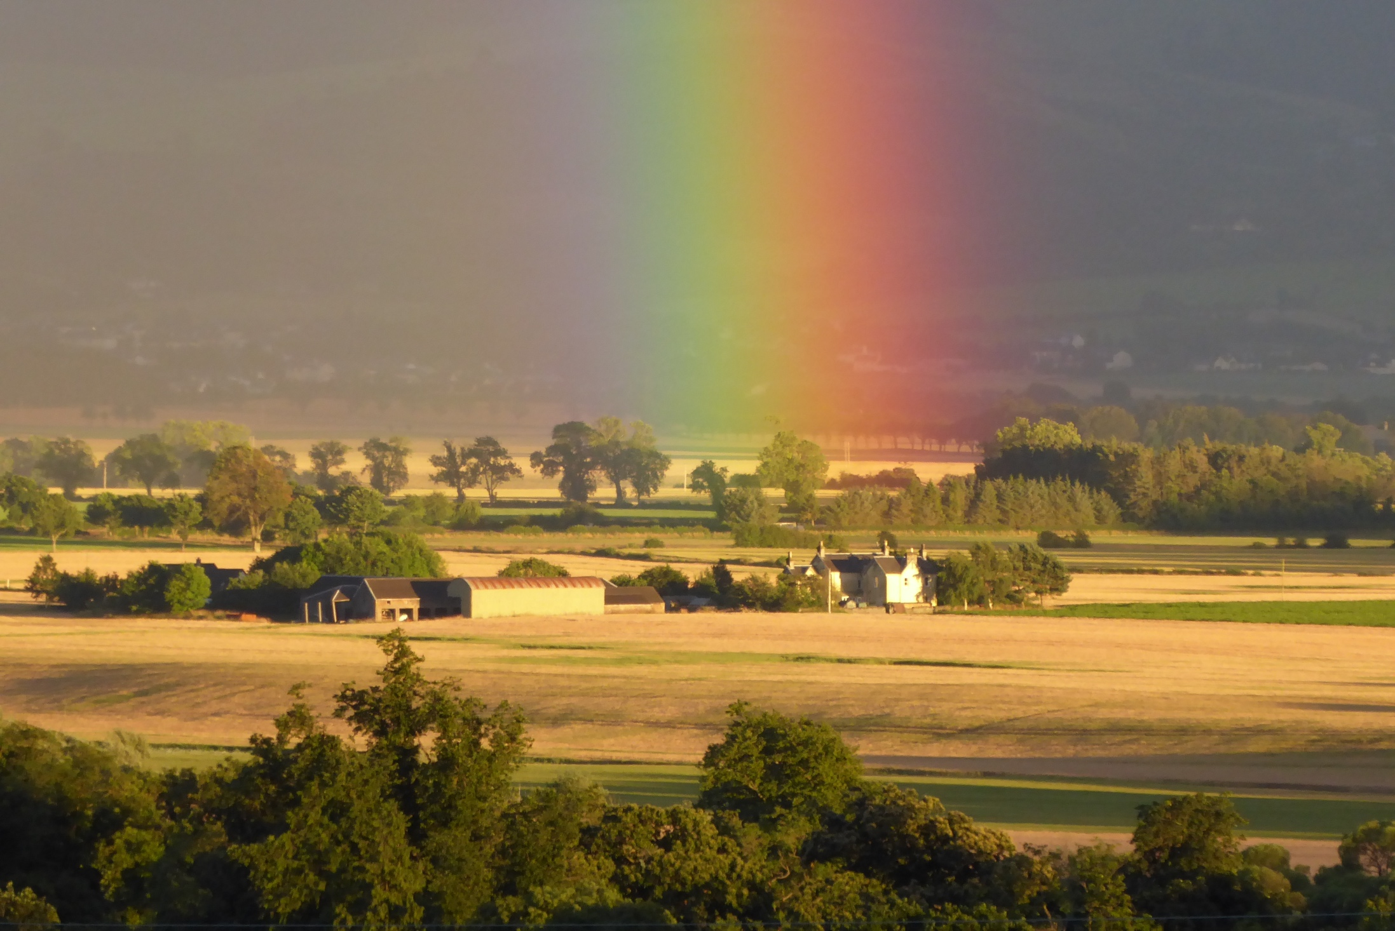 Q

U

E

S

T

October and November 2018

Letter from the Rector

Dear friends,



Dear Friends,

Happy harvest!

By the time you receive your copy of Quest we will once again have celebrated our Harvest thanksgiving in St. John’s. A lovely time of the year, a time when we come together in our beautiful building, beautifully decorated with flowers and fruit in abundance, as we give thanks to God the creator of all things for all that we have and the many blessings we receive. We are very fortunate. I hope like me, storm Ali did little damage to your properties; it was a very wild day and evening indeed. May we continue to pray for those less fortunate than ourselves and especially those abroad caught up in hurricanes and storms. For those who have lost lots, may we ever intercede for them.

On a different note, I’m very happy to commend this copy of our magazine to you. My thanks go to David Willington and his team for being so willing to take this on. If you ever feel that you could and would like to contribute to the life of our Church in any way, then do speak with me. There are always jobs to be done about the place and what is that old saying, ‘Many hands make light work’!

This Autumn it will be a joy to welcome our new Bishop to the diocese Ian Paton and his wife Carrie. I look forward very much to working with Ian and in time welcoming them into our community here in St. John’s.

Outside of my ministry with you in St John’s, I feel very honoured to have been approached to become the Chaplain for the Scottish Episcopal Institute. This is something I am very much looking forward too, getting to know staff and students alike. A real blessing for me is that their residentials are in Kinnoull! It has been a joy to welcome Annie Hughes into our midst, Annie comes from SEI on placement with us as a student training for Ordained Ministry.

God is good, seen in many different people and situations. I continue everyday in my prayers to give thanks. You are great folks and four years on this month, I still feel very blessed to be among you all.

Looking forward to seeing you all in Church as we continue our Ministry and Mission together.

With love,

Graham

SEI Placement

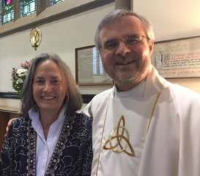

Annie’s background is in teaching and education. She is married to David and has two girls. In this her final year of ordination training, she is delighted and privileged to be able to share in the prayer, worship, outreach and fellowship of Rev’d Graham and his congregation at St John’s.

Annie is pictured with the Rev’d Dom Ind after Annie preached at St.Saviour’s, Bridge of Allan.

October and November

***Weekly Services***

Sunday 8.30 a.m. Holy Communion

Sunday 10.30 a.m. Sung Eucharist

Thursday 11 a.m. Communion, coffee and a chance to chat

S***pecial Services***

7th October 9.30 a.m. Matins

21st October 6.30 p.m. Evensong

2nd November 11.00 a.m. All Souls

4th November 9.30 a.m. Matins

18th November 6.30 p.m. Evensong

25th November 6 – 7.30 p.m. NiteKirk

**Eternal Rest**

Alan Charles Hepworth, 17th July 2018, member of the Cathedral. Our love and prayers to those who mourn.

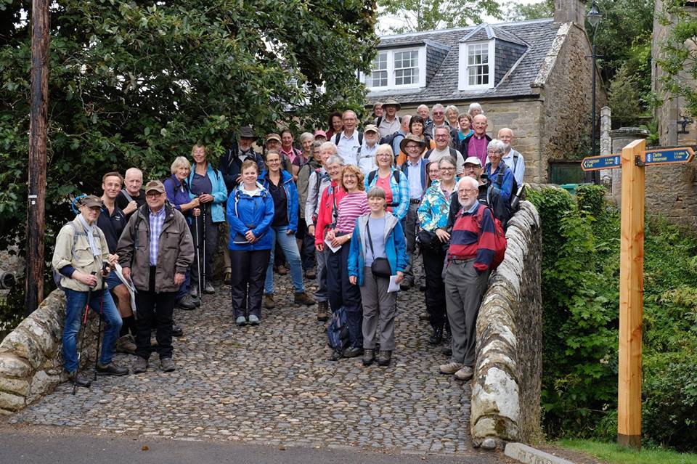

Diocesan Pilgrimage 2018

28th July, the day of our first diocesan pilgrimage to St Andrews, was a day to remember. It was a day of sunshine and showers, a day for prayer and song, conversation and laughter.

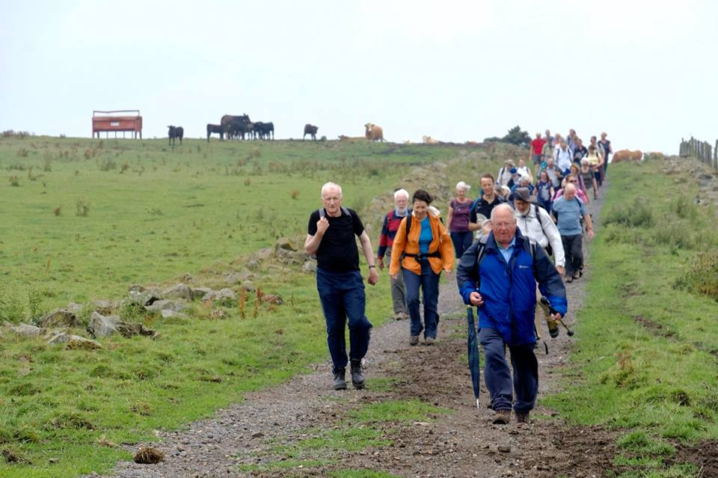

Those hardy souls who tramped the first five miles from the picturesque village of Ceres were rather damp when they arrived at Craigtoun Park. It was easy to distinguish between them and those who joined them for the second half of the journey.

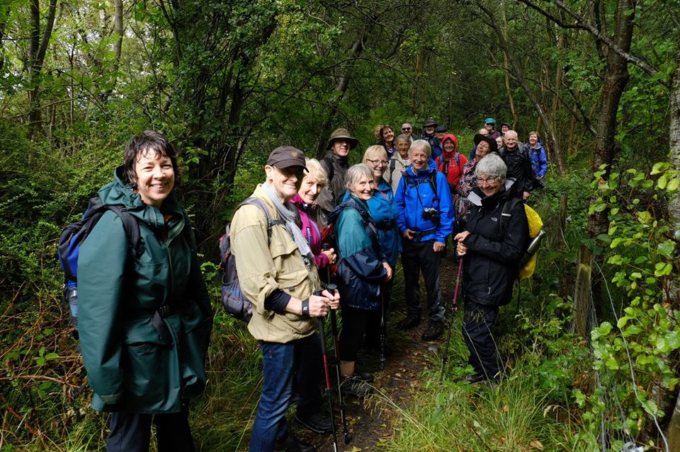

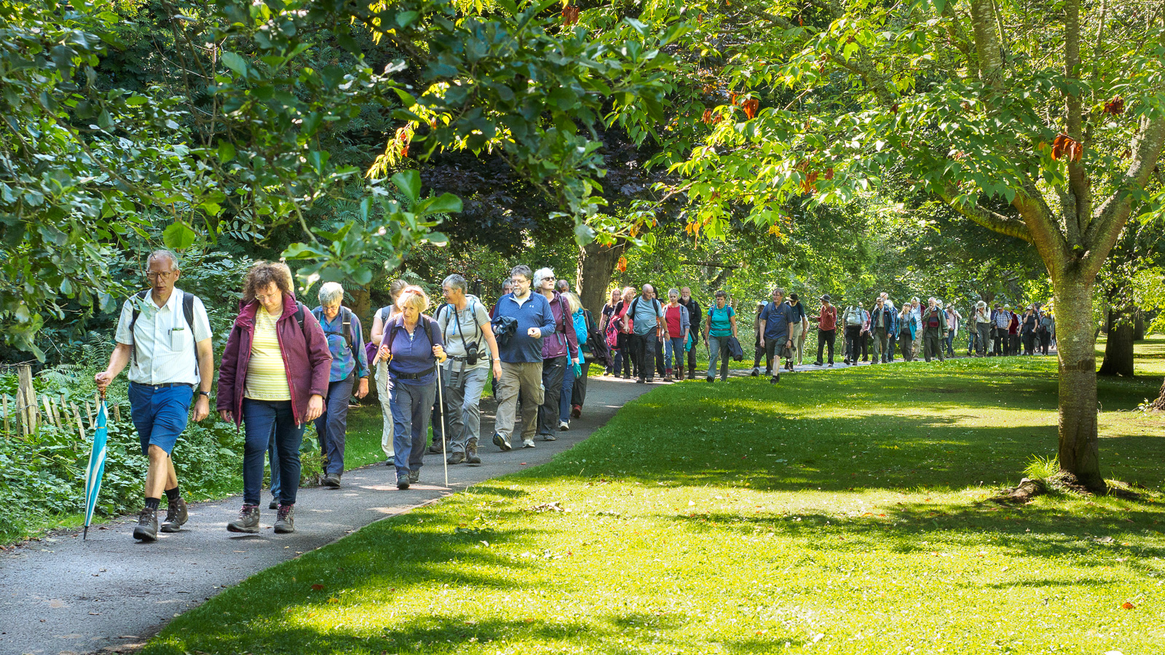The excitement grew as we caught a glimpse of the twin towers of the Cathedral of Saint Andrew in the distance and the sun had dried clothes and hair by the time we arrived at Hallow Hill where even more pilgrims were waiting for us.

A long line of about 70 walkers threaded their way along the Lade Braes towards St Andrew’s Church. There were Episcopalians from Leven, Lochgelly, Kinross, Dunfermline, Rosyth, Aberfoyle, Doune, Dunblane and Dollar, Stirling, Perth, Blairgowrie, Forfar, Cupar, Ladybank and St Andrews. There were Catholics from Tayport and Dundee, Methodists and members of the Church of Scotland, two medievalists from Glasgow University and a couple who live near the Camino in France.

We arrived at our destination in bright sunshine and then made our way to All Saints for a welcome cup of tea and evensong.

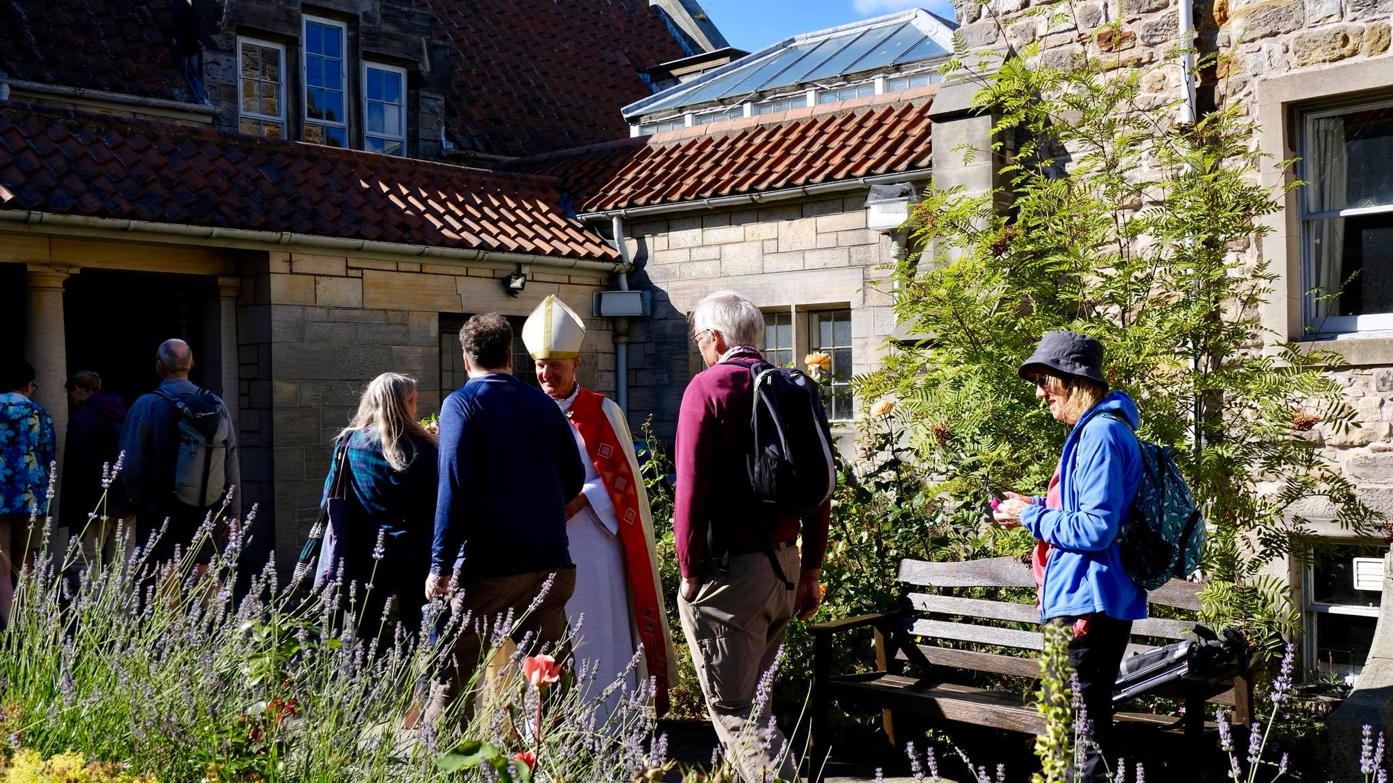

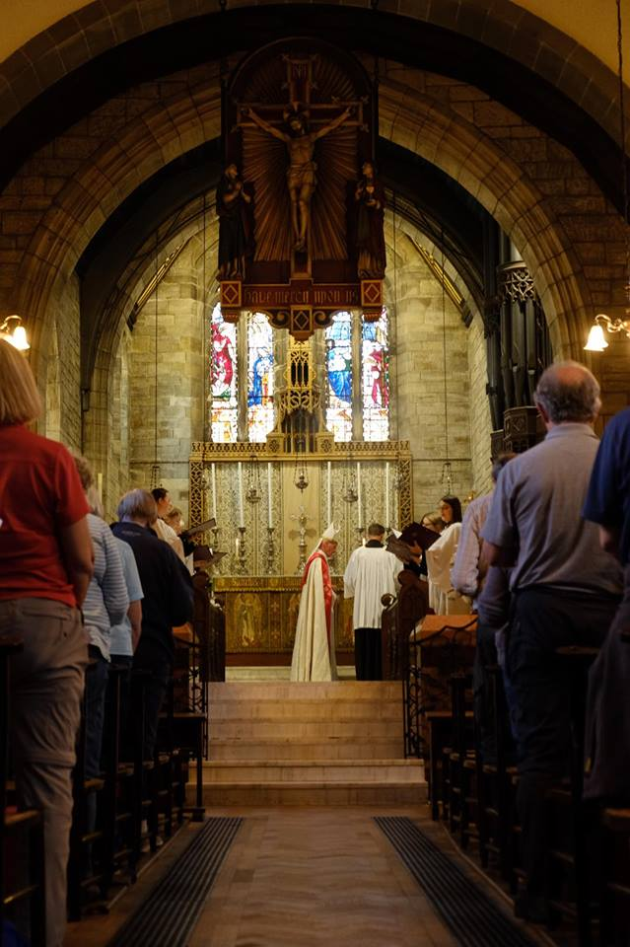Thank you, Alasdair Coles and Nick Cooke for organising the pilgrimage, to the two churches at St Andrews for their hospitality and to all who led the reflections along the way and the final worship, including bishops Bruce and Bob. On the day, there was talk of another pilgrimage next year and some were even planning a trip to walk the Camino. In the meantime, should any church group like to walk part of the Fife Pilgrim Way in the coming months, Alasdair would be happy to be your guide. He can be contacted at [alasdaircoles@btinternet.com](mailto:alasdaircoles@btinternet.com).

Nerys Brown

Choir

At the start of this term the choir said farewells to Judy and Alison who have both retired from regular singing, and also to Tim who has decided to move on to different pastures. I want to thank them all for their dedication and service to St John’s. Each of them has contributed greatly to the musical life of this place.

This leaves the choir in a bit of a pickle! With only three regular members I don’t think it’s really possible to continue to have a choir Sunday by Sunday. However, I am aware of a reasonable number of people who would be willing to sing on an occasional basis.

After discussions with Graham this then is the plan: we will try and have a choir to sing an anthem at some of the major festivals throughout the year. Please come and join us!

Rehearsals will be Thursdays 7:30pm, in the church, for two or three Thursdays before each festival.



Remembrance (11th November)

Carol Service (16th December)

Mothering Sunday (31st March 2019)

Easter Sunday (21st April)

Pentecost (9th June)

Patronal Festival (23rd June)

We will keep this under review. Hopefully we can restore a permanent choir in the future, but that will only be possible if we have people to sing in it.

Robin Miller

Sunday Lectionary

**October 7 Pentecost 20**

*Matins* Joshua 3. 7-17, Psalm 136, Matthew 10. 1-22

*Eucharist* Psalm 8, Hebrews 1. 1-4; 2. 5-12,Mark 10. 2-16

**October 14 Pentecost 21**

Psalm 90. 12-17, Hebrews 4. 12-16, Mark 10. 17-31

**October 21 Pentecost 22**

*Eucharist* Psalm 104. 1-9, 25, 37b, Hebrews 5. 1-10, Mark 10. 35-45

*Evensong* 1 Corinthians 10. 1-13, Psalm 141, Matthew 12. 1-21

**October 28 Pentecost 23**

Psalm 126, Hebrews 7. 23-28, Mark 10. 46-52

**October 31 All Souls**

**November 4 Pentecost 24**

*Matins* Daniel 2. 1-11, 25-48, Psalm 111 (117), Matthew 5 1-12

*Eucharist* Psalm 119. 1-8, Hebrews 9. 11-14, Mark 12. 28-34

**November 11 Remembrance**

Psalm 90, 1 Corinthians 15, John 6. 37-40

**November 18 Pentecost 26**

*Eucharist* Psalm 16, Hebrews 10. 11-14 (15-18) 19-25, Mark 13. 1-8

*Evensong* Rev 4 1-11, Psalm 95 or 97, Matthew 13. 24-30, 36-43

**November 25 Christ the King**

Psalm 93, Revelation 1. 4b-8, John 18. 33-37

Bible Society Competition

Recently the Bible Society ran a competition for children to build a biblical scene using Minecraft.

Minecraft is a computer game, which allows users to build worlds of their invention from basic components. It can be thought of as a virtual equivalent of Lego.

Our son Bryn entered. Unfortunately, he was not selected as one of the winners. However, we were impressed with his entry and thought that the readers of Quest would enjoy seeing it.

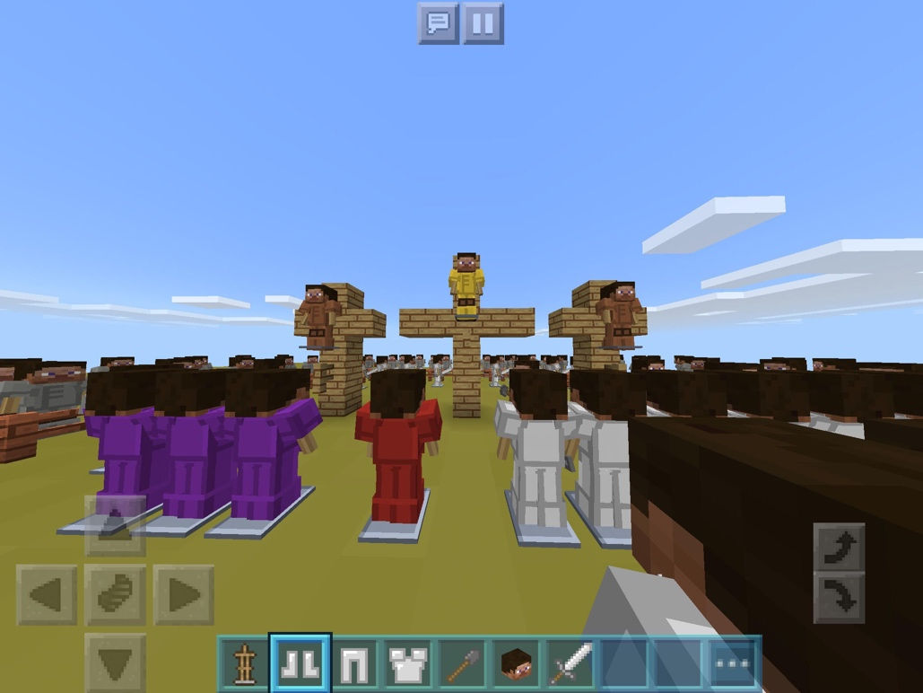

All the entries may be seen on the Bible Society’s website at [www.biblesociety.org.uk](https://www.biblesociety.org.uk/latest/news/bible-story-minecraft-competition-2018/). Once in the site, press on the link marked Latest and then look for a further link labelled Bible Story Minecraft Competition 2018.

Ed Hockaday

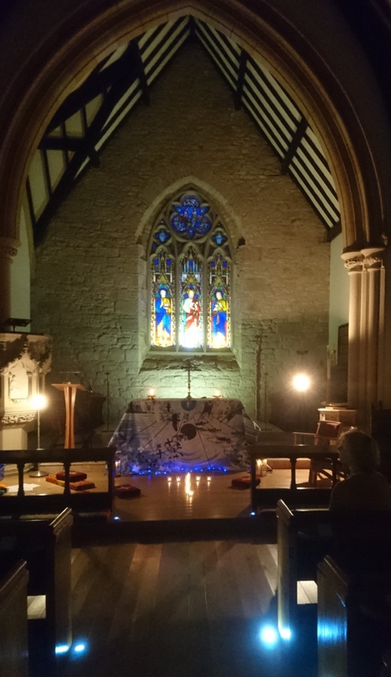Nitekirk takes place on the last Sunday of each month but there will be no Nitekirk in October. It provides an opportunity to take time out from busy lives to be still and respond creatively to a variety of words, music, images and crafts.

Nitekirk

Past themes have included Living Stones, Light in the Darkness, At the Shoreline and Labyrinth.

All are welcome to drop in at any time between 6-7.30pm (please note the earlier finish time).

If you’d like to know more, please speak to Gordon Murch, Sarah Axford or Graham Kingsley-Rowe.

***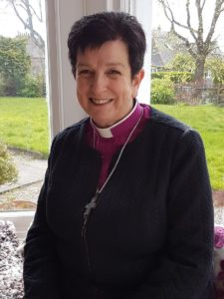*BISHOP ANNE DYER**

will use her *Picturing*

*Prayer* blog to explore

***Seeing Injustice,***

***Imagining Change***

**Saturday DECEMBER 1,**

**St John’s, Princes Street, 11 – 4 p.m.**

Organised by the Diocesan Gender Justice Group.

Contact Elaine Cameron for more information

Buggy Club

Every Thursday   9.30 - 11am in the Threshold

Buggy Club is for mums/carers and toddlers from birth to pre-school.

Mum’s Chat:

* It's lovely to talk to other Mums and to watch the kids playing.
* Great to see the babies grow, develop and form friendships.
* The volunteers are really welcoming and friendly.
* The arts and crafts activities are really engaging.
* It's lovely to relax with our tea and toast, it's quite informal.
* It's great when you have more than one child as the volunteers play and help with the babies and toddlers.
* It's like a little family, but we love getting to know new children and their mums/carers.

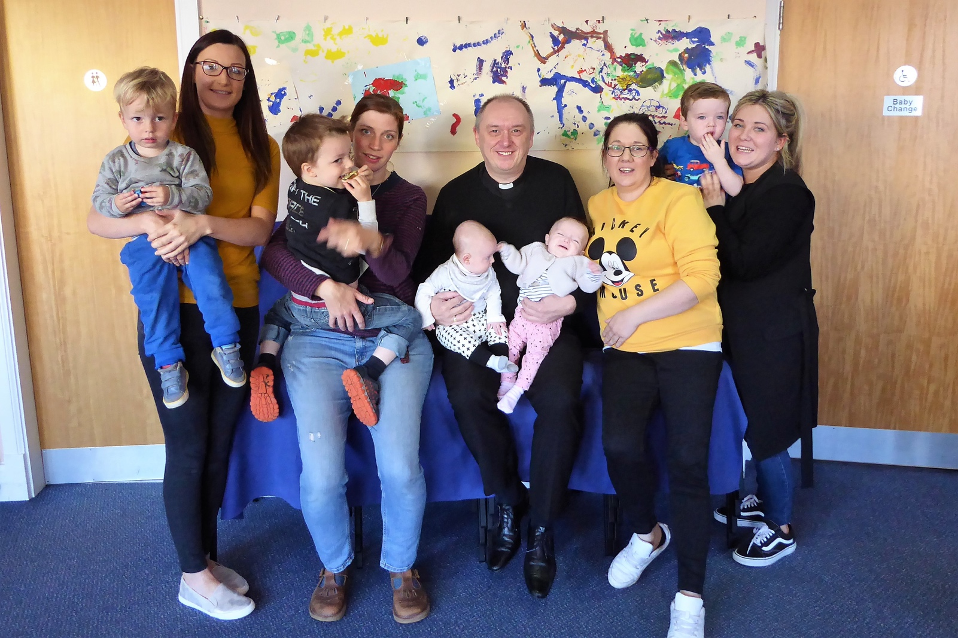

St John’s Fellowship

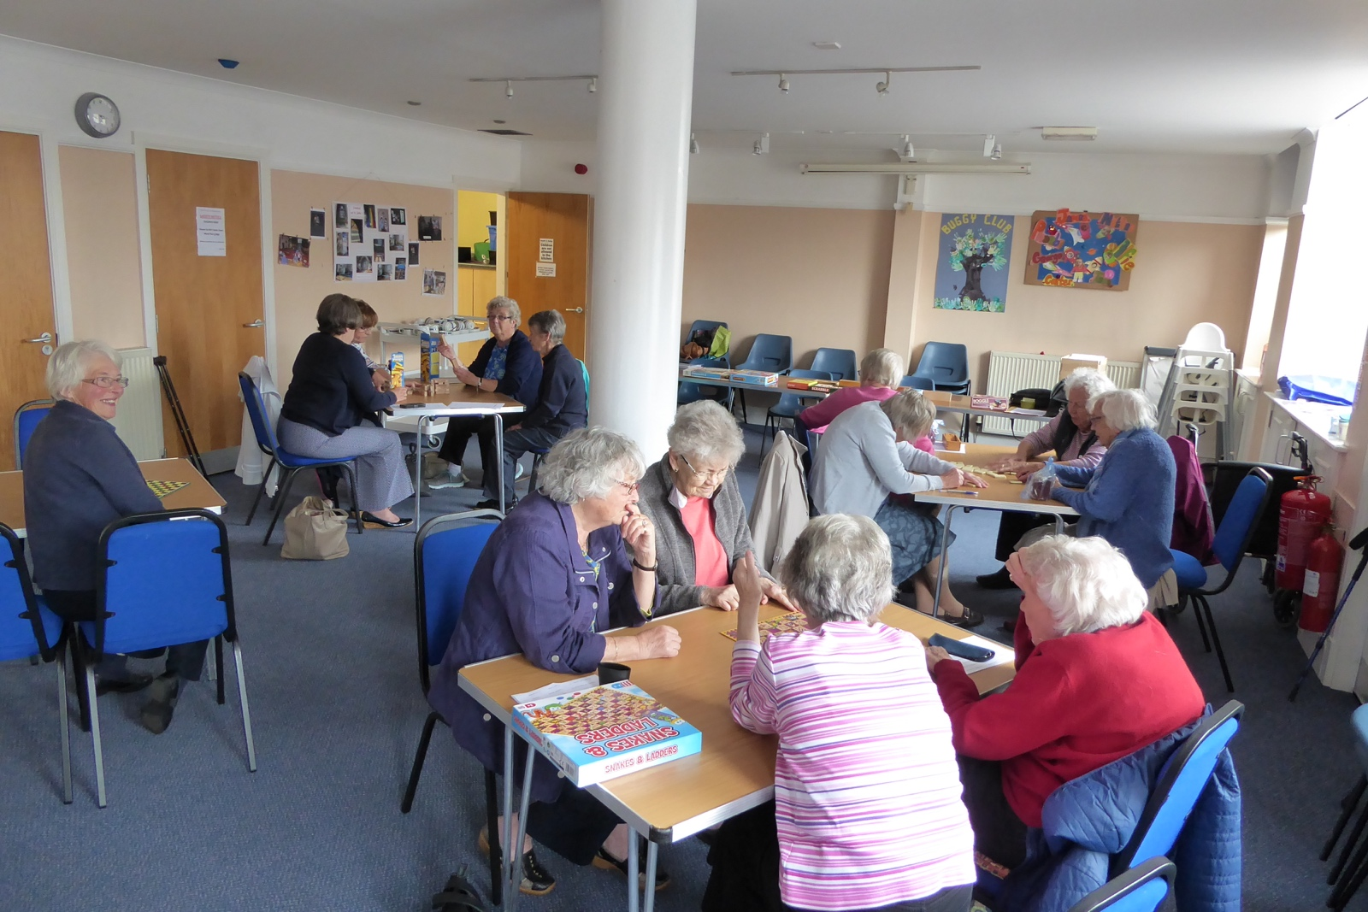

St John's Fellowship started their 2018/19 calendar on September 12th with a games afternoon. Snakes and ladders, dominoes, Jenga and checkers were chosen, with great competition between the players, and much laughter. Tea, cakes and chatter followed. Homemade jam, marmalade and beautiful cards were on sale.

The next meeting with be at 2.30 p.m. on Monday 8th October for afternoon tea at The Restaurant, McDiarmid Park.

Joyce Sampson

The Coventry Litany of Reconciliation

Following the bombing of the mediaeval Cathedral in 1940, Provost Howard had the works ‘Father Forgive’ inscribed on the wall behind the Altar of the ruined building.

***All have sinned and fallen short of the glory of God.***

The hatred which divides nation from nation, race from race, class from class.

*Father, forgive.*

The covetous desires of people and nations to possess what is not their own.

*Father, forgive.*

The greed which exploits the work of human hands and lays waste the earth.

*Father, forgive.*

Our envy of the welfare and happiness of others.

*Father, forgive.*

Our indifference to the plight of the imprisoned, the homeless, the refugee.

*Father, forgive.*

The lust which dishonours the bodies of men, women and children.

*Father, forgive.*

The pride which leads us to trust in ourselves and not in God.

*Father, forgive.*

Let us therefore be kind to one another, tender hearted, and forgiving of one another as God in Christ forgave us.

*Amen*

**Pastoral Care in our Church**

The Pastoral Team met recently and would like to share our thoughts about how we offer a pastoral service in the church.

**Situations that might lead to a visit**

Following publication of Quest there will be a check to see which magazines remain unclaimed at the back of Church after three Sundays. Members of the Pastoral Team will then meet and consider whether the team should try and deliver the magazine. It is possible that a simple explanation is offered if the recipient is around when Quest is being delivered but it could be that it is discovered there is a problem and a pastoral visit might be appropriate. Any subsequent visit by members of the Pastoral Team would be by prior arrangement.

If anyone in the congregation has a concern for someone who may be vulnerable or in need, they may approach any member of the Pastoral Team. This will be referred to Rev Graham. He will then decide whether a visit should be made and by whom.

**Carrying out a visit**

Visits will be made either by Rev Graham or by two lay members of the Pastoral Team.

**Hospital Visits and Home Communion**

Hospital visiting and the giving of Home Communion, while a major part of the pastoral care of the church, remain the responsibility of the Rector. Rev Graham carries out hospital visits and Home Communion is given either by him or members of the Ministry Team.

The members of the Pastoral Team are: Rev Graham Taylor, Christine Bracewell, Elaine Cameron, Jean Hendry, Graham Kingsley-Rowe, Rob Mackay, Alan MacPherson and Joyce Sampson.



**Reachout to touch theWorld this Christmastime**

No wrapping paper required, ribbon or tags, just knowing that by offering hospitality to a “*Stranger* *Soon to Become Friend*”, the experience will stay with you and your guest long after recycling the wrapping paper, storing decorations and finishing off the cold turkey!

Here at HOST UK we offer you the opportunity to engage in an extra special Christmas-time by opening your home to an international student for whom the alternative would be, not only being far from home and loved ones but marking time in lonely halls of residence.

HOST UK arranges visits for International students all year round but as can well be imagined, festive season hospitality is greatly sought after and valued. Our “festive season” will include the period in the Christmas run up, as well as New Year. Your guest will be someone keen to experience British life with all its special traditions and culture…and keen to share those of their home country. Your hospitality will be a unique gift, invariably remembered and treasured. Your gift to each other and to the world will be that of growing friendship, peace and understanding.

Please consider this opportunity and remember that if the festive season is difficult for you, we do operate all year round and hosting can become one of your New Year Resolutions!

If you should like to know more, please go to our website [www.hostuk.org](http://www.hostuk.org) or leave us a message on

<http://visits.hostuk.org/Public/ApplyToBecomeAHost>

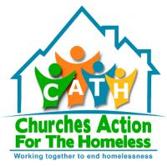

**CATH would like to invite all of our supporters**

**Past and present to our 25th Anniversary**

**On**

**Tuesday 30th October 2018**

**At**

**Day Centre, Ladeside, St Catherines Road, PH1 5RY**

**10.00 AM – 3.00 PM**

***DON’T FORGET***

***ALL SOUL’S SERVICE***

***Friday 2nd November at 11 a.m.***

***An opportunity to remember a loved one.***

***Sung Eucharist with an act of remembrance***



May they rest in peace

and rise in glory

Contact Information

|  |  |  |  |
| --- | --- | --- | --- |
| Rector | Rev Graham Taylor | 245922 | [*rector@episcopal-perth.org.uk*](mailto:rector@episcopal-perth.org.uk) |
| Retired Assistant Clergy | Rt Rev Bruce Cameron  Rev Fergus Harris |  |  |
| ***Church Officers***  Rector’s Warden  People’s Warden  Administrator  Lay Representative  Alternate Lay Rep  Vestry Secretary  Treasurer Health and Safety  PVG  Director of Music | ***Mail to be sent to Office***  Gordon Murch  David Willington  Eleanor McGourty  Graham Kingsley-Rowe  TBA  Judy Norwell  Peter Marsh  Graham Kingsley-Rowe  Malcolm Moore  Robin Miller | 827034  813787  634999  248120    575040  248120  639963  625903 | ***@episcopal-perth.org.uk***  *church-warden@*  *office@*      *secretary@*  *treasurer@*  *hands@*  *pvg@*  *music@* |
| ***Team Convenors***  Casting the Net  Ministry  Finance  Communications  Children  Buildings and Eco  Social | TBA  Alan McPherson  Peter Marsh  TBA  Jean Hendry  David Maclehose  TBA | 552337  575040  623603  636147 |  |
| ***Church Activities***  Intercessors Group  Flowers  Magazine  Fellowship  Buggy Club  Young Church  Links  Traidcraft  Christian Aid  PACT  Threshold bookings | Tony Mason  Christine Bracewell  David Willington  Jean Hendry  Eunice McPherson  Jean Hendry  Ruth Harris  Rhiannon Miller  Elaine Cameron  Jean Hendry  Eleanor McGourty | 627870  552817  813787  623603  552337  623603  621379  625903  441172  623603  634999 | *office@episcopal-perth.org.uk* |

From the Editorial Team

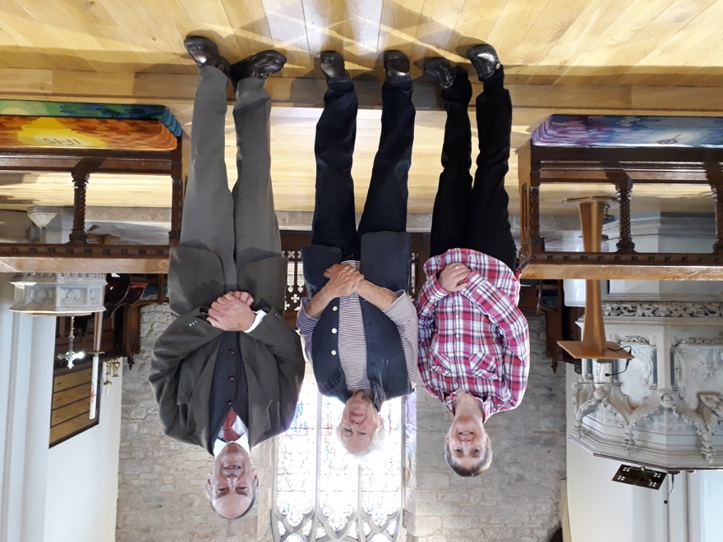

The new Editorial Team:

Cath Bodrell

Doreen Kneller

David Willington

Thanks very much for everyone’s contributions to this issue and to those who helped prepare it for printing and distribution.

Due to the rising costs of producing Quest if anyone would like their copy to be emailed please forward your email address to: [office@episcopal-perth.org.uk](mailto:office@episcopal-perth.org.uk). There is also a donation tin at the back of the Church where any contributions towards Quest would be gratefully received.

**Please hand in or email all items to David Willington for our December/January issue by:**

**Sunday 18th November**

*Cover Photo – thanks to Joyce Sampson*

www.scotland.anglican.org www.standrews.anglican.org

St John the Baptist

Scottish Episcopal Church

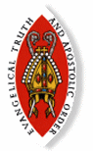Princes Street, Perth, PH2 8LJ

www.episcopal-perth.org.uk

01738 634999

Scottish Charity Number SC 011398

Rev Graham S. Taylor

23 Comely Bank, Perth PH2 7HU

01738 245922

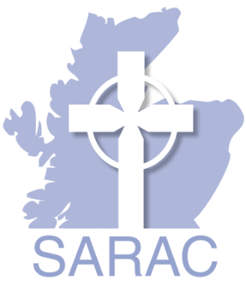rector@episcopal-perth.org.uk

In partnership with

the Scottish Association of

Retired Anglican Clergy

